PRESS RELEASE
Contact: press@dirimart.com
Dirimart Presents Berke Yazıcıoğlu at SPARK 2024
Istanbul, 10.02.2024 – Dirimart is proud to present Berke Yazıcıoğlu at SPARK 2024, featuring an innovative exploration of the intricate relationship between desire and order through the lens of visual art and classical music. Yazıcıoğlu, a visionary artist whose work transcends traditional boundaries, draws profound inspiration from European music of the 19th and 20th centuries, channeling the genius of Stravinsky and Ravel into his latest visual masterpieces.
Yazıcıoğlu’s standout project, The Rite of Spring, is a visual homage to Stravinsky's epic ballet, transformed into a series of 11 tapestries that blend silk and chenille to narrate the ancient pagan celebration of spring's arrival. This collection not only adapts the orchestration into geometric patterns and figurative narratives but also employs a unique color palette to represent different instruments, embedding Germanic runes to add layers of meaning and interpretation.
Produced during his residency at the Sarabande Lee Alexander McQueen Foundation in London, Yazıcıoğlu's choice of weaving highlights his intent to create art that is both sequential and deeply embedded within its medium, offering a fresh perspective on storytelling through textiles.
Berke Yazıcıoğlu's broader body of work delves into the complex dynamics of desire and its interplay with societal structures, showcasing a delicate balance between personal aspirations and communal norms. His art serves as a poignant commentary on the human condition, inviting viewers to reflect on the boundaries imposed by society and our intrinsic urges to transcend them.

Visit Us at SPARK 2024: From 24 March to 27 March at Marx Halle, Dirimart welcomes all visitors to this experience at booth E3.

For more information, press inquiries, or to request high-resolution images, please contact press@dirimart.com directly.

About Berke Yazıcıoğlu:
Born in 1993 in Istanbul, Turkey, and currently residing in London, UK, Berke Yazıcıoğlu has cultivated a distinguished career that spans various mediums and themes. A graduate of the School of the Art Institute of Chicago, Yazıcıoğlu has showcased his talent in numerous solo and group exhibitions, earning acclaim for his ability to navigate the complexities of human desire and societal expectations through his art.

A Brief Look Into His Works:
Berke Yazıcıoğlu's selected works will be displayed at Dirimart's booth E3 at SPARK 2024. Attendees are invited to experience firsthand the depth of Yazıcıoğlu's artistic inquiry and the alluring interplay of music and visual art.

Highlighted Works:

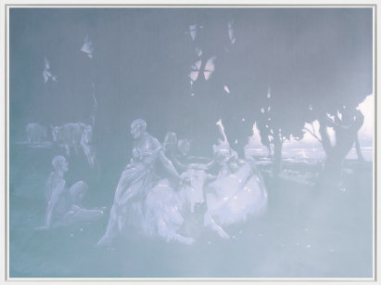
Daphnis and Chloe After Arthur Lemon, 2023

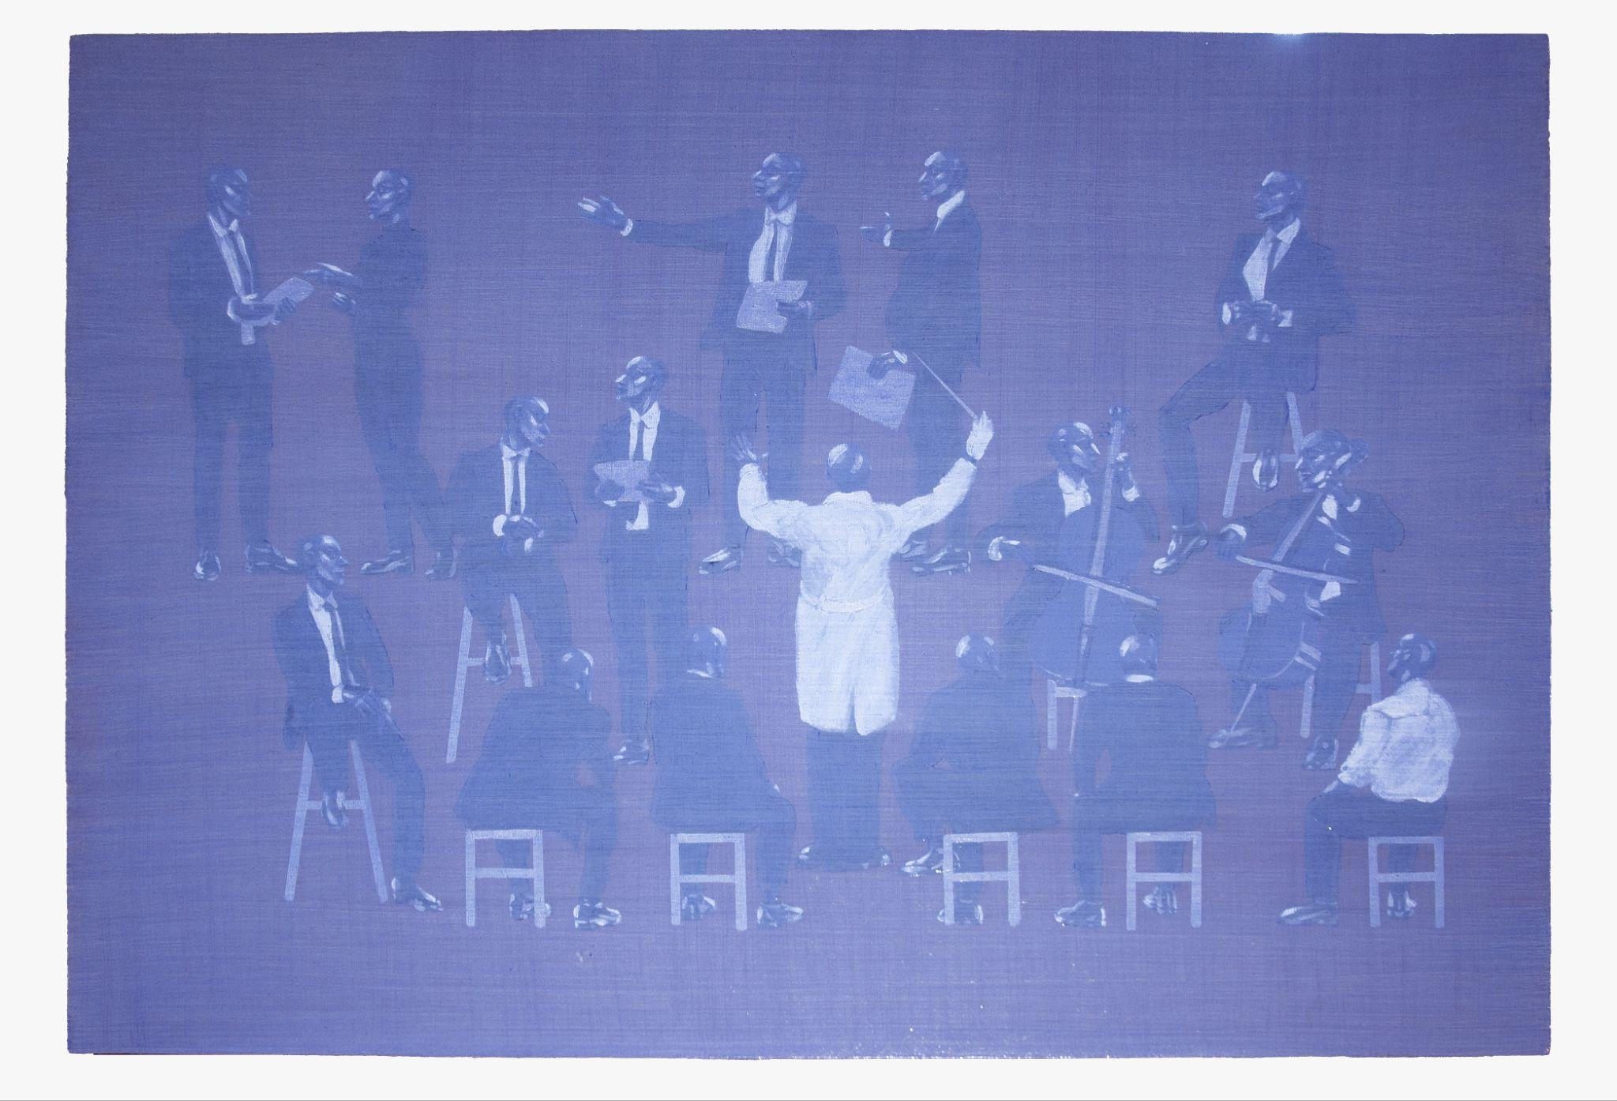
Auction, 2023

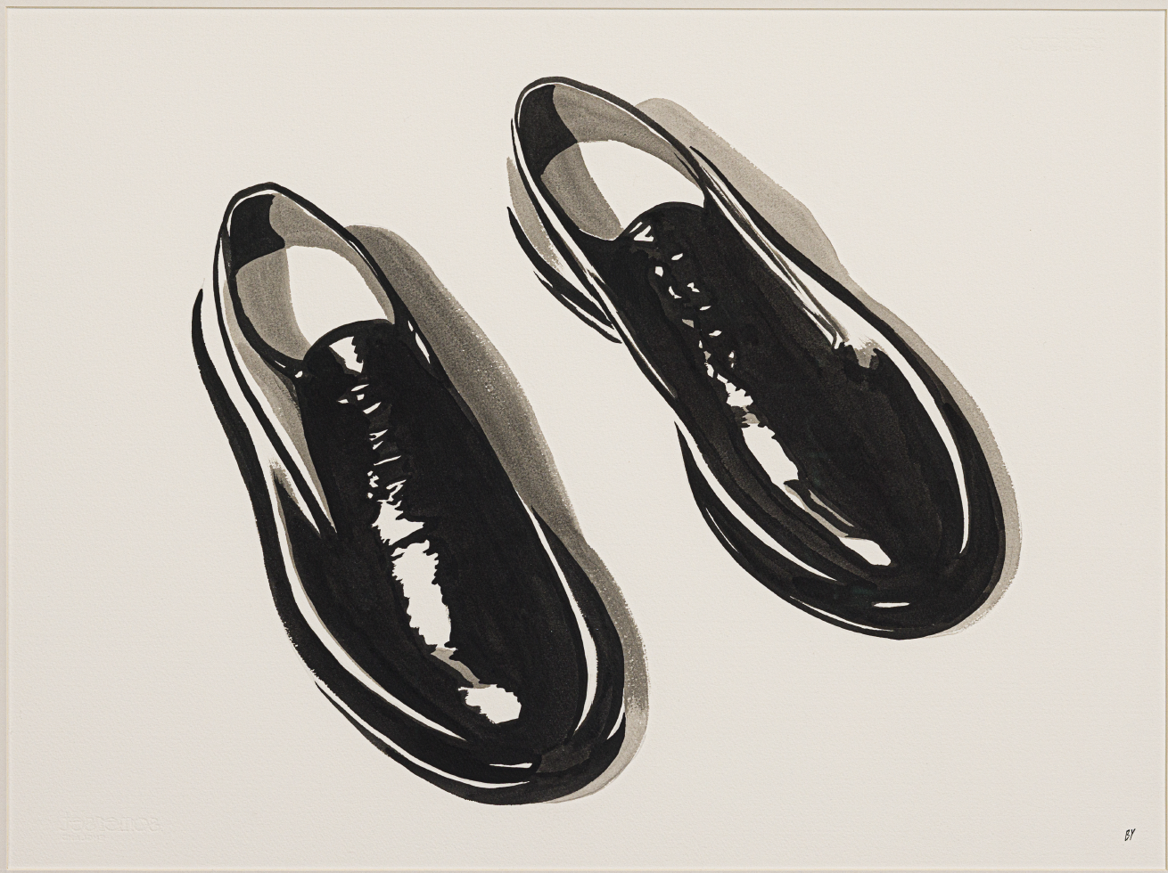
Oxfords IV, 2023

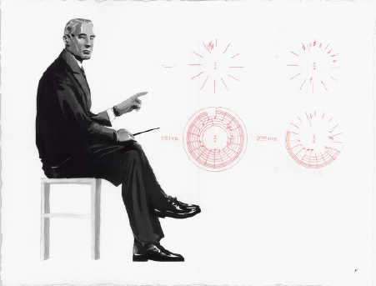
Study for Ravel Presenting the Circularity, 2023

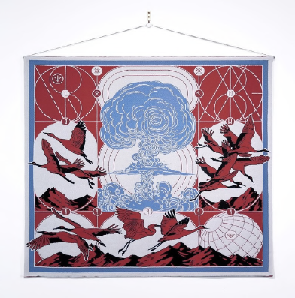
The Rite of Spring Act I Scene 6, 2020

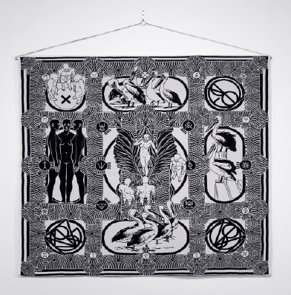
The Rite of Spring Act II Scene 4, 2020

